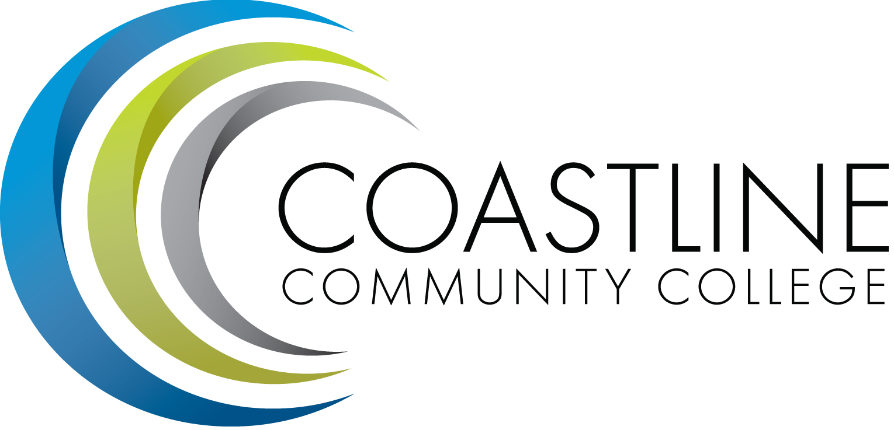

College Professional Development & Leadership Committee Agenda
10/04/2016
3:00 pm to 5:00 pm
College Center, Distance Learning Conference Room

Committee Mandate: To promote, coordinate, recommend, and support the creation and delivery of professional development and leadership programs that increase the effectiveness of our institution and the satisfaction of our employees.
- CALL TO ORDER
  - Roll Call

Present | Members
 | Bob Nash, Co-chair, Associate Dean, Distance Learning & Prof. Development
 | Cheryl Chapman, Co-chair, Academic Senate Representative
 | Mitchell Alves, Faculty Success Center Coordinator
 | Judy Garvey, MECTBD Administrator Representative
 | Elaine Hill, Classified Senate Representative
 | Ken Leighton, Academic Senate Representative
 | Dorothy McCollom, Classified Senate Representative & Committee Support
 | Renate Akins, Director of HR
 | Randall Warwick, Academic Senate Representative
GUESTS: Chris Blackmore, Daniel Pittaway

  - Welcome
  - Adoption of Agenda
  - Approval of Minutes: 09/06/2016

- SPECIAL REPORTS & UPDATES
  - CCC SharePoint for Committees/Planning Councils/Work Groups/Ad Hoc Panels Presentation (Chris Blackmore)
  - Training Faculty & Staff on Student Non-Cognitive Factors Associated with Success (Daniel Pittaway)

- ACTION ITEMS
  - Group will review Summer Institute Survey and propose topics for next year
  - Group to consider role and mandate of our Committee once the Flex Committee is created
  - Bob will provide URL to PLN for members to review.
  - Renate will provide access to Cornerstone demo for review

- STANDING REPORTS
  - None

- DISCUSSION ITEMS
5.1 Hosting a Meeting Around Archived Webinars (Mitchell Alves)
5.2 Speaker or Presentation Addressing “How Do I Say That”, “Conflict Management” and/or “Interpersonal Relationships”

- ANNOUNCEMENTS (1-2 minutes per)
  - 4th Annual Active Learning Leaders Conference: October 29, 2016 (Mitchell Alves)
  - The Leadership TransitionTM Workshop (Bob)
6.2 Next Meeting, November 8, 2016 at 3:00 pm
- ADJOURNMENT

